ESSA General Assembly: Security Standards,
Cyber Resilience and the Future of Cash

- Leading association in the physical security industry met in Frankfurt
- Experts from all over the world visit the Main metropolis

Frankfurt/M. – Nov. 2025. Physical security is more important than ever – as demonstrated by the key topics at the annual general assembly of the European Security Systems Association (ESSA) in November. The two-day event in Frankfurt focused on new security standards, the Cyber Resilience Act (CRA) and battery fires. But it also addressed the role of cash in a digital world. Workshops on topics such as service on safes and ISO standards rounded off the programme. ESSA Managing Director Falko Adomat welcomed 135 security experts from around the world to the event.

News on security standards – integration of the CRA
ESSA initially focused on the latest developments relating to its well-known security standards EN 1143-1 and EN 1300. These include new requirements for safes and high-security locks, as well as the integration of CRA into existing standards. These measures are intended to further increase the security and resilience of the products.

New ESSA white papers provide inspiration
A new white paper from the leading international association for the physical security industry reveals widely varying laws on weapon storage in Europe – a highly controversial topic in today's climate. Another paper deals with the secure construction of vault rooms. The ESSA is also planning to publish a paper on the service life of safes in December. ‘Our analyses provide facts, ideas and recommendations for action for manufacturers and operators,’ says Falko Adomat.

Cash remains indispensable
Speaker Olivier Strube from the European Central Bank (ECB) Banknote Directorate emphasised the indispensable role of cash. Despite digitalisation, coins and notes remain an essential and resilient means of payment that serve as a reliable option even in times of crisis. The digital euro is intended to complement the use of cash and create a European digital payment platform.

International Leadership Award 2025 for Harald Lüling
Harald Lüling is the winner of the ESSA International Leadership Award 2025. He led the organisation for 20 years as its chairman. ‘During this time, Harald Lüling made a significant contribution to the further development of the security industry. And he always rendered outstanding services through his neutral and committed leadership,’ emphasised Falko Adomat in his laudatory speech.

Obituary for Slavka Marinič
An obituary was dedicated to Slavka Marinič. The Slovenian, who passed away in the summer, was a member of the ESSA Board from 2005 to 2019 and winner of the 2023 Leadership Award. ‘She was deeply committed to promoting the EN 1143-1 standard in Eastern Europe,’ emphasised Adomat.

The next Annual General Assembly is scheduled for November 2026. At that time, ESSA plans to present a new white paper on battery storage cabinets, among other things.
Text 2.791 Z. characters incl. spaces

The press release and photo are also available for download here.

BU | Photo No. | Photo
Around 135 security experts from all over the world travelled to Frankfurt for the ESSA Annual General Assembly | 280 | 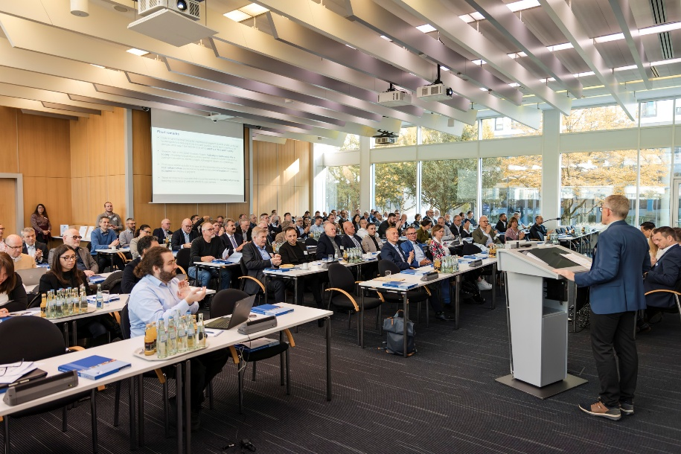
Olivier Strube from the European Central Bank (ECB) emphasised the indispensable role of cash | 282 | 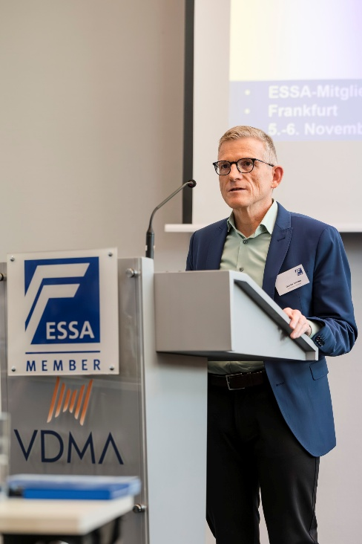
Harald Lüling (right) is the winner of the ESSA International Leadership Award 2025 – the award was presented by ESSA Managing Director Falko Adomat | 281 | 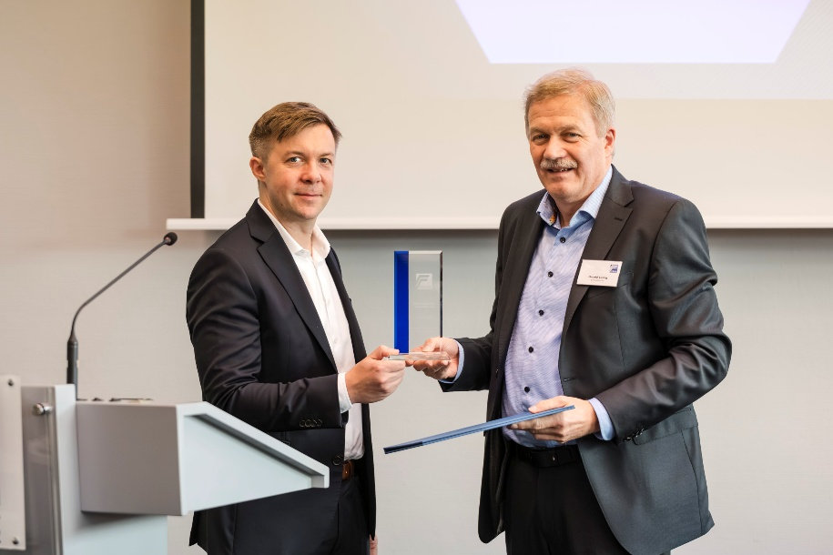
Photo/s: ESSA, Abdruck honorarfrei

Background ESSA
ESSA - The International Security Association is the leading international association of the physical security industry, based in Frankfurt/Main. ESSA currently has over 100 members from five continents.

Data protection and cancellation of press releases
The topic of data protection is highly topical and also of central importance to us. You will receive regular press releases from us on journalistically relevant topics and news. The continued use of your e-mail address for this purpose is based on our business interest in this regard and is carried out on the basis of Art. 6 para. 1 lit. f) GDPR. You can object to your email address being used for this purpose at any time by sending an email to essa@mali-pr.de or by clicking on this link.

