Change of ESSA Chairperson:
Myriam Bevillon Succeeds Harald Lüling
"We need to prepare the security industry so that it can address future risks and challenges"

Frankfurt/M. – 26 March 2026. Change at the top of ESSA: Myriam Bevillon of Gunnebo Safe Storage AB is new chairperson of the European Security Systems Association (ESSA). She is taking over the reins from Harald Lüling, who has significantly shaped the leading international association of the physical security industry for 20 years. The CEO of Burg Wächter will remain a member of the ESSA Board. His successor, Myriam Bevillon, aims to continue the market- and needs-oriented course while bringing in her own style. Here is a conversation with her about priorities, challenges, obstacles, goals, and visions.

What are the current priorities of ESSA?
My main area of focuses includes finding out about trade barriers, and how to overcome them is one. Another is "one stop testing" with mutual test result recognition from approved testing laboratories. I also want to make sure that our standards are still in line with what happens on the market. For instance, we need to speed up the transition of the safe lock standard EN 1300. It is important to include and define borders of operating locks with smartphones.

Where do you currently see the greatest challenges for physical security?
There are a few challenges. As mentioned speeding up the normative part so that it catches up with technology and has been on the table for a while, another one is the recent boom in AI and its unknown consequences, and the last one is the sustainability challenge, where the global physical security business is well behind.

What are the most difficult barriers in the international market?
Previously, different standards were the main challenge, but new government trade barriers have made things more complicated.

In your opinion, which security issues relevant to ESSA will become more important?
Cyber-attacks, also powered by AI! Not new, but still prevalent, also fire risks related to storage of Lithium-Ion batteries, as more and more batteries are used.

What are the organization's long-term goals—where do you see ESSA in 10 or 15 years?
I think this needs to be thought through, and reviewed, and I see this as one task for the ESSA board, also to discuss with members. Our industry is well-recognized for its strong emphasis on security and confidentiality, ensuring we consistently uphold the highest standards. While this approach remains a core strength, we also need to complement it with accelerated responsiveness to meet evolving needs and demands, as markets are expecting a greater agility to adopt new technologies and ways of working.

What is your vision for the future work of ESSA?
We collectively need to be more active for the benefit of all. For the future, it will be crucial to position the security industry in a way that enables it to address emerging risks and security challenges. We can work together as an industry for instance in standardization on the security requirements while of course always respecting the European and antitrust laws.

Text 3.105 Z. characters incl. spaces

The press release and photo are also available for download here.

BU | Photo No. | Photo
Myriam Bevillon is the new chairperson of the European Security Systems Association (ESSA) | 283 | 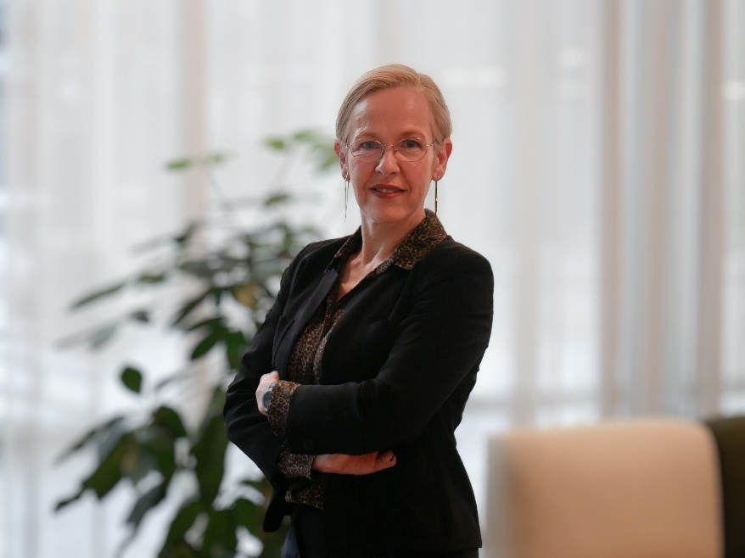
Photo/s: ESSA

Background ESSA
ESSA - The International Security Association is the leading international association of the physical security industry, based in Frankfurt/Main. ESSA currently has over 100 members from five continents.

Data protection and cancellation of press releases
The topic of data protection is highly topical and also of central importance to us. You will receive regular press releases from us on journalistically relevant topics and news. The continued use of your e-mail address for this purpose is based on our business interest in this regard and is carried out on the basis of Art. 6 para. 1 lit. f) GDPR. You can object to your email address being used for this purpose at any time by sending an email to essa@mali-pr.de or by clicking on this link.

